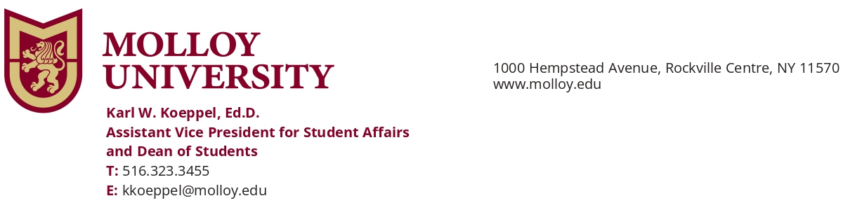
Dear Community Partner,
As part of Molloy University’s 2026 Family & Alumni Weekend, we are excited to invite local businesses and community partners to participate in our Family & Alumni Weekend Carnival on Saturday, October 24, from 11:00 a.m. to 2:00 p.m. on Public Square Lawn on Molloy’s Rockville Centre campus. Note that in the event of inclement weather, the fair will be moved inside Public Square Lobby. I am including a campus map as well for your convenience.

The Carnival will bring together Molloy students, parents and family members, alumni, and friends of the University for an afternoon of activities and community. The event will feature food, music, carnival games, inflatables, arts and crafts, a pumpkin patch, and more.

As a participating community partner, you will have the opportunity to connect directly with members of the Molloy community, promote your business or organization, distribute information and promotional materials, and, if applicable, sell products or merchandise during the event.

The event is FREE and there is no cost to participate. Each participating organization will be provided with one six-foot table, and two chairs. We ask that participating organizations provide any additional materials, signage, displays, or equipment they may need for their space. Setup will start at 10:00 a.m.

We value our relationship with the surrounding community and hope you will consider joining us for what promises to be a fun and engaging afternoon at Molloy. To participate please register using the form here.

Additional event details and participation information will be shared with registered organizations as the event approaches.

We hope to welcome you to campus on October 24!

Warmly,

Karl Koeppel, Ed.D.
Assistant Vice President for Student Affairs
& Dean of Students

